N**umerical Programs:**

* **1. Even or odd:**

1. **a. Write a program to check whether the given number is even or odd:**

Even -> number which is completely divisible by 2. Focus on the remainder part so take modulus % operator

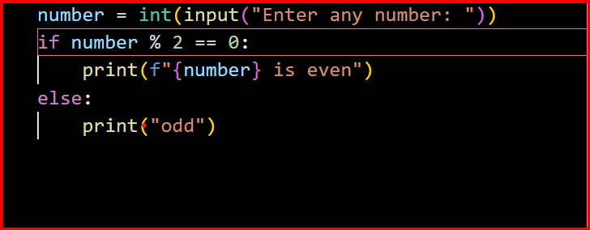

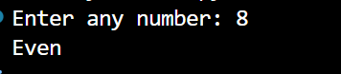

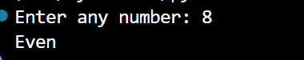

--------------------------------------------------------------------------------------------------------------------------------------2. Write a program to check whether the given number is even or odd using customized function:

* Identify the major logic and copy
* Include a function declaration and paste the logic
* Include the parameter required by the function to perform the logic.
* Design the output from the function
* Call the function and store the output from the function to reuse the output.

1. 